SIMATS ENGINEERING

ASSESSMENT TOOL 3

COURSE NAME: INTERNET PROGRAMMING COURSE CODE: CSA4301

COURSE OUTCOME COVERED

CO 4: Formulate data-driven web solutions using XML, XSLT, and JSP within the MVC framework. (L4)

Assessment Tool : Class Test

Weightage: 10%

QUESTIONS: Total Marks: 20

Explain the fundamental concepts used in web development by defining the following terms with suitable explanations: XML, JSP, MVC architecture, XSLT, XML Schema, JSTL, PHP, Database Connectivity, and Parser. Your answer should clearly describe the purpose and role of each concept in web applications.

Explain how the above technologies are interconnected in building a web application. Describe how XML is structured and validated, how JSP and PHP are used for server-

side processing, how MVC architecture organizes the application, and how database connectivity and parsers contribute to data processing and communication.

Code of Conduct:

I G.Althaf / 192372004 (Name / Reg No) certify that this submission is my original work and that I have adhered to the guidelines specified for this assessment.
I understand that any violation of academic integrity rules will result in disciplinary action.

G.Althaf
Signature of the student:

RUBRICS FOR CALCULATION:

Criteria | Weightage | Level 4 –  Exemplary | Level 3 –  Proficient | Level 2 –  Developing | Level 1 –  Beginning
Concept Understanding | 25% | Clearly explains all concepts with complete accuracy and depth | Minor gaps in understanding | Basic understanding with some errors | Incorrect or very limited understanding
Content Coverage | 25% | Covers all  required topics comprehensively | Covers most  topics with minor omissions | Covers some topics only | Very few topics covered

Criteria | Weightage | Level 4 –  Exemplary | Level 3 –  Proficient | Level 2 –  Developing | Level 1 –  Beginning
Technical Accuracy | 20% | All explanations are technically correct and precise | Minor technical errors | Some  incorrect or  vague explanations | Major technical errors
Integration of Concepts | 15% | Effectively connects and  relates concepts logically | Some connections  made with minor gaps | Limited connections  between concepts | No clear relationship  between concepts
Clarity & Presentation | 15% | Well-structured, clear, and easy to understand | Mostly clear  with minor issues | Somewhat unclear or  poorly organized | Poorly structured and  difficult to understand

XML (Extensible Markup Language)

XML is a markup language used to store and transport data in a structured format. It allows developers to create their own tags and is commonly used for exchanging data between different applications.

Example: <student><name>Bhavya</name></student>

JSP (JavaServer Pages)

JSP is a server-side technology used to create dynamic web pages using Java. JSP allows Java code to be combined with HTML and is commonly used to generate web content dynamically.

MVC Architecture

MVC stands for Model–View–Controller. It divides an application into three parts:

Model: Handles data and business logic.

View: Displays information to the user.

Controller: Handles user requests and connects the Model and View. This makes applications easier to develop and maintain.
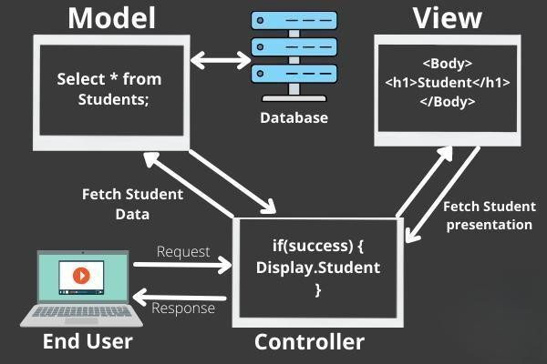

XSLT (Extensible Stylesheet Language Transformations)

XSLT is used to transform XML data into other formats such as HTML, XML, or text. It is useful for displaying XML data in a user-friendly format.

XML Schema

XML Schema, also called XSD, defines the structure and rules of an XML document. It specifies elements, attributes, data types, and their relationships. It is used to validate XML data.

JSTL (JSP Standard Tag Library)

JSTL is a collection of standard tags used in JSP pages. It provides features such as loops, conditions, formatting, and database operations, reducing the need to write Java code directly in JSP.

PHP (Hypertext Preprocessor)

PHP is a server-side scripting language used to create dynamic and interactive web pages. It can process forms, communicate with databases, manage sessions, and generate HTML content.

Database Connectivity

Database connectivity is the process of connecting a web application to a database to store, retrieve, update, and delete information. Technologies such as JDBC, PDO, and database APIs can be used for this purpose.

Parser

A parser is a software component that reads and analyzes data according to a defined structure. In web applications, XML parsers read XML documents and convert them into a form that programs can process.

- Interconnection of These Technologies in a Web Application

These technologies work together to create a complete web application.

XML → XML Schema → Parser → Server-side Processing → Database → MVC → JSP/PHP → User
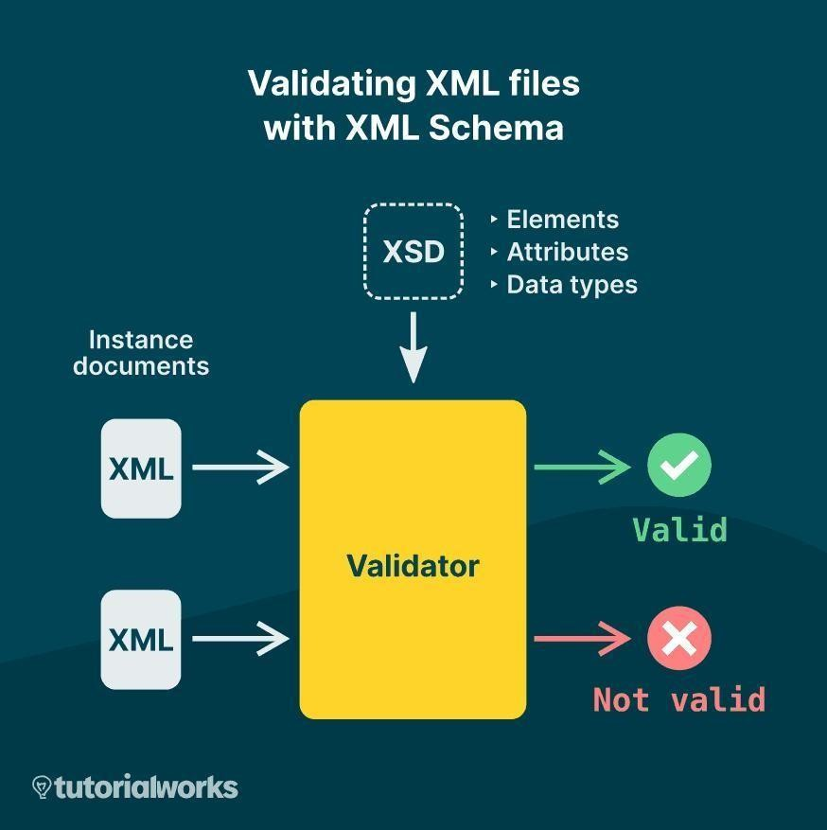

  - XML stores and transfers structured data between different parts of an application.
  - XML Schema (XSD) defines the rules and structure of the XML document and checks whether the XML data is valid.
  - An XML parser reads the XML document and allows the application to access and process its data.

JSP or PHP performs server-side processing. It receives user requests, processes data, and generates dynamic web pages.

Database connectivity allows the server-side application to communicate with databases and perform operations such as insert, search, update, and delete.

MVC architecture organizes the complete application. The Model manages data, the View displays the result, and the Controller handles requests.

In Java-based applications, JSP and JSTL can be used in the View layer to display dynamic information.

XSLT can transform XML data into HTML or another suitable format for presentation. Finally, the processed information is sent to the user's browser as a web page.

Thus, XML handles structured data, XML Schema validates it, parsers process it, JSP/PHP perform server-side operations, databases store information, and MVC organizes all these components into a maintainable web application.
